Location: |  | Date: |  | Time:
WP# (Type): |  | FM: |  | Phone:

H&R Required: | Yes No N/A | Person Contacted:
RADCON Required: | Yes No N/A | Person Contacted:
EC&P Required: | Yes No N/A | Person Contacted:

Type of recovery hardware used (check all that apply):
Winch System | Tow Rope | Pull Cable | Nylon Sling | Pushing | Other:

Total Length recovery hardware: _____________________
Standoff Distance: (Minimum 2 times length of recovery hardware): _________________________

Type of attachment Point (Check all that apply):
Hook | Equipment Pin | Shackle/pin | Sling | Manufactured point | Other:

Type of equipment used for recovery:
Dozer | Excavator | Loader | Farm Tractor | All terrain Forklift | Other:

Evaluation of ground conditions:
Blacktop/Concrete | Lawn/Grass | Gravel/Stone | Shallow Mud
Wheel Deep Clay/Sand/Muck | Body Deep Clay/Sand/Muck | Other:

Type of Communication: | Radio Hand Signals Verbal
Vehicle Construction Equipment Spotter (VCES) Required | Yes No

Minimum Capacity Required (MCR) (MCR=W+ARR+AGR)
- Weight (W) of equipment (include fluids, implements, screens, cargo): (W): _____________
- Additional Rolling Resistance(ARR): (ARR): _____________
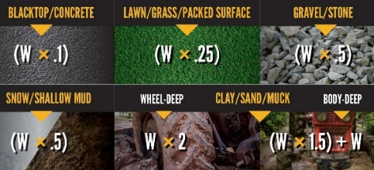
Note: Additional Rolling Resistance multipliers assume the wheels are level with each other.

- Additional Gradient Resistance(AGR) (NOTE: use zero if no slope): (AGR): ____________
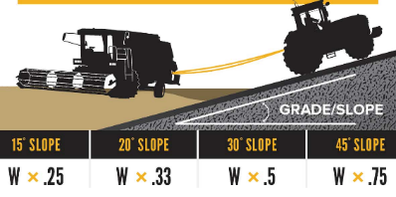

- Plus Plus Equals
WARNING – If Recovery Equipment or Attachment Points is less than Minimum Capacity Required (MCR), DO NOT USE!!! CONTACT SUPERVISOR
(W) (ARR) (AGR) (MCR)

Capacity of recovery equipment (≥MCR): ________________
Capacity of attachment point: (≥MCR): ________________

Description of recovery method: ___________________________________________________________________________________________________________________________________________________________________________________________________________________________________________________________________________________________________________________________________________________________________________________________________________________________________________________________________________________________________________________________________________________________________________________________________________________

Recovery Plan Approvals:

Subject Matter Expert: __________________________________________________________
Print Name Signature Badge No.

Maintenance Supervisor: __________________________________________________________
Print Name Signature Badge No.

Facility Manager: __________________________________________________________
Print Name Signature Badge No.

NOTE: This recovery plan does not take the place of proper work control

© 2023. Developed by UCOR (United Clean Up Oakridge) in collaboration with the NORA Construction Sector Council Struck-by Work Group. For additional resources related to working safely with and around heavy equipment, visit https://cpwr.com/struck-by-hazards.

