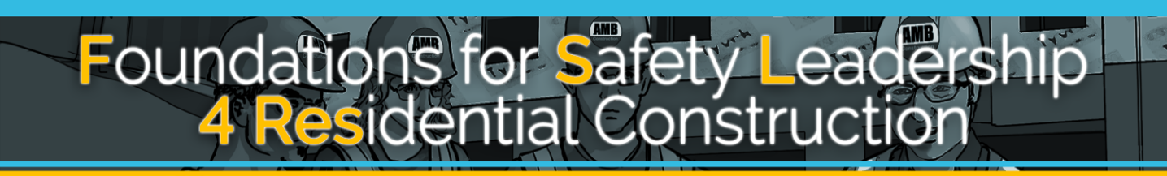

Student Handout for Additional Scenarios

`

The Foundations for Safety Leadership 4 Residential Construction (FSL4Res) course was developed collaboratively by

Development of the FSL4Res training was supported with funding from a cooperative agreement to CPWR - The Center for Construction Research and Training (#U60OH009762) from the National Institute for Occupational Safety and Health (NIOSH) The FSL4Res is based on the original FSL training created by CPWR under an earlier NIOSH cooperative agreement (#OH009762) The contents are solely the responsibility of the authors and do not necessarily represent the official views of NIOSH. All Rights Reserved.

TABLE OF CONTENTS

Applying Leadership Skills in Real World Scenarios 4
  - FRITZ’S SHORTCUT 5
  - STORMY WEATHER 6
  - OH SOLAR MIO 8
  - IT’S TOO HOT 10

Applying Leadership Skills in Real World Scenarios

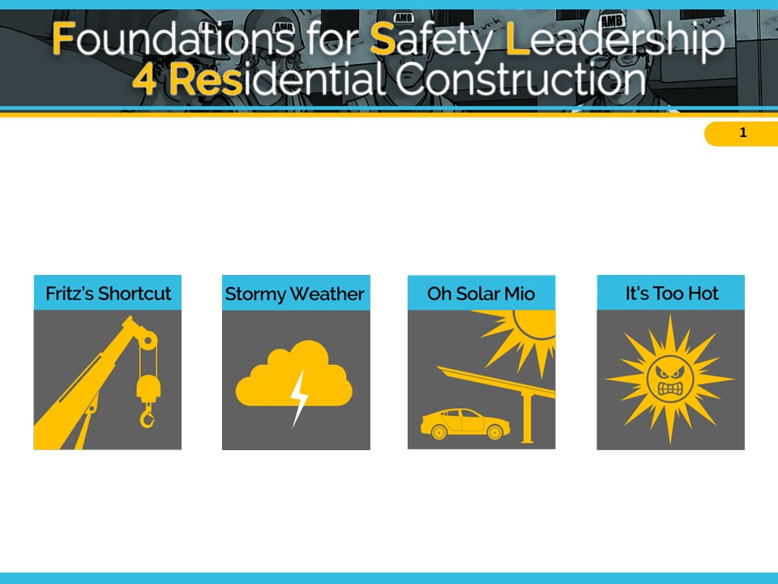

` 4

1. FRITZ TAKES A SHORTCUT

Fritz – Mighty Mechanical Foreman –Sheet Metal Subcontractor Elliot – Mighty Mechanical Experienced worker

Situation
The crane operator gave Fritz, Mighty Mechanical’s foreman the wire rope slings and shackles they will need to lift 2 HVAC units to the roof and Fritz gave them to Elliot, an experienced worker.
While inspecting the equipment, Elliot notices that one sling is severely kinked and a shackle is damaged. So he tells Fritz they should ask the crane operator for replacements.
Fritz knows that getting replacements would take hours and earlier he caught hell from the GC about the tight timeline. So he tells Elliot to go with what they have. Elliot tells Fritz that he is not comfortable with the decision to proceed with the current rigging equipment because it will create a really unsafe situation. Fritz reminds him that as his foreman Elliot just needs to do what he says.
As one of the units is lifted, the kinked sling abruptly stretches, one end of the unit drops 6 inches, and the damaged shackle breaks open….causing the unit to fall to the ground severely damaging it and nearly crushing a worker.
Outcome A
Later, Fritz tells Elliot not to mention the damaged rigging equipment to anyone.
Elliot is angry about Fritz’s request, but he wants to keep his job.
Outcome B
Later, Fritz tells Elliot he was right to question his decision and says he did it because the GC has been pressuring him. But if that worker had been crushed because of his bad decision he couldn’t have lived with himself.
Fritz calls for a safety stand-down. He repeats to the crew what he told Elliot adding that from now on he’s going to hold a daily safety huddle to discuss the day’s tasks and how to eliminate hazards that may come-up.
He says he has learned the hard way to listen to his crew's safety concerns and expects everyone to report unsafe situations. Fritz ends by saying that he doesn’t want to lose any of them due to poor decisions, pride or ego … some of the bad behaviors he displayed today.

2. STORMY WEATHER

Sam – AMB, Inc. Superintendent
Francis – Aiden’s Carpentry Foreman
Evan – Aiden’s Carpentry Experienced worker
Filip – Parson’s Sheet Metal Foreman
Elaine – Parson’s Sheet Metal Experienced worker
Tad – Parson’s Sheet Metal Trainee

Situation
At the morning huddle, AMB’s superintendent, Sam, tells the sheet metal and carpentry crews that today’s biggest task is to prepare the roof for the HVAC systems. After they discuss the steps involved and the potential hazards that may come up, Sam adds that they need to get started because the afternoon weather forecast is calling for severe thunderstorms with a chance of lightening.
Once on the roof, Francis and Evan from Aiden’s Carpentry cut two holes for the sheet metal workers to install the HVAC duct work. Since they won’t be starting the installation until after lunch, Francis and Evan screw down pieces of plywood over the holes and put out a few safety cones.
Outcome A
After lunch, as Parson’s sheet metal crew is getting ready to start work, Filip, the foreman at Parson’s Sheet Metal, notices dark clouds coming in. At the same time, Elaine, an experienced sheet metal worker, realizes that she’s the only one who has fall protection, which they will need when they remove the plywood that’s covering the holes. She calls to the trainee Tad to hold-up for a minute.
As she’s telling Tad that everyone needs to be wearing fall protection before they can start their work, Filip interrupts her saying that it’s going to start raining really soon and they can’t waste any time going to get getting fall protection. And besides, he says, there’s really no risk of falling since they’re not working at the edge of the building and the hole won’t be open for that long before they install the duct work.
As Elaine starts to explain that the holes in the roof present a fall risk no matter how long they are open, she notices that Filip is glaring at her, so she stops talking. Tad is pleased because it means he won’t have to trudge down to the trailer to get the fall protection equipment.
Outcome B
After lunch, as Parson’s Sheet Metal crew is getting ready to start work, Filip, the foreman, notices dark clouds coming in. At the same time Elaine, an experienced sheet metal worker, realizes that she’s the only one who has fall protection, which they will need when they remove the plywood that’s covering the holes. She calls to the trainee Tad to hold-up for a minute.
As she’s telling Tad that everyone needs to be wearing fall protection before they can start their work, Filip starts to interrupt her but stops.
While he would really like to get started before the storm, he realizes the situation gives him an opportunity to recognize Elaine for taking ownership of safety and for demonstrating good safety behavior in front of Tad. So he lets Elaine continue explaining why it’s important they all should be wearing fall protection.
After she’s done, Filip thanks her for being a good role model and asks Tad to go down and get the fall protection equipment. He adds that if the stormy weather starts, they’ll just have to wait it out and maybe even finish-up tomorrow.

Ferris – Alan’s Operators Foreman
3. OH SOLAR MIO
Ethan – Alan’s Operators Experienced worker
Emily – Alan’s Operators Experienced worker

Situation
It’s 7 am. Operating engineers Ethan, Emily, their foremen Ferris, and a few iron workers are in The Cain Building parking lot checking out the flatbed trailer that’s loaded with mounting structures needed to build solar carports.
Earlier that week, Ferris had developed a lift plan that took into account the size and weight of the materials, the ground conditions, and the crane’s load and lift capacity. However, late yesterday afternoon the GC needed the larger crane at a different job site and the only one that was available to rent was smaller with less capacity.
In the past, Ferris has had the GC’s superintendent make the go/no-go decision, particularly when a change could delay the schedule. Unfortunately, AMB’s superintendent isn’t at the jobsite yet, so Ferris must decide whether or not to do the lift using the smaller crane.
As Ferris considers what to do, one of the iron workers starts pressuring him to begin hoisting the steel mounts immediately, reminding him that the carport installation is behind schedule and the GC is already ticked-off. The ironworker’s pushing and the fact that they are behind schedule lead Ferris to put his concerns aside and go ahead with the lift.
Outcome A
Ferris asks Ethan and Emily to get the slings and attach them to the first structure. Emily is worried about the size of the crane and tells Ferris that she’s concerned the crane may be too small to do the lift safely. Ferris responds defensively, saying that he’s sure it will be okay to do the lift.
Ethan and Emily look at each other before they reluctantly get the slings. As Ferris lifts the load and extends the boom, he feels the bed of the crane begin to shift and the outrigger starts to lift off the ground. Luckily, he is able to retract the boom just in time to prevent a possible disaster.
Outcome B
Ferris asks Ethan and Emily to get the slings and attach them to the first structure. Emily is worried about the size of the crane and tells Ferris that she’s concerned the crane may be too small to do the lift safely.
Ferris hears what Emily is saying and in the back of his mind he recognizes that she’s right. He also realizes that if ignores her comment, then all his talk about expecting his crew to openly voice jobsite safety concerns is meaningless, and that his role as a safety leader will be greatly weakened.
So, instead of going ahead with the lift, Ferris brings everyone together and tells them that even though the GC may not be happy about it, he is taking Emily’s concern seriously and is going to postpone the lift. He goes on to say that he’ll let AMB’s superintendent know what’s going on as soon as he gets to the jobsite and work with him to find a larger crane they can use, hopefully by the end of the day.
Before he starts discussing alternative job assignments, Ferris turns to Emily and, in front of everyone, thanks her for having the courage to speak up and question his decision about the smaller crane, adding that he appreciates it when she and others on the jobsite take their role as a safety leader seriously.

4. IT’S TOO HOT, TOO HOT, TOO HOT BABY…

Franco – AMB, Inc. Foreman
Emilio – AMB, Inc. Experienced Carpenter

Situation
Late one afternoon, Franco, a foreman for AMB, notices Emilio, an experienced carpenter, pouring a jug of water over his head. Franco suspects heat exhaustion.
He shouts to Emilio that he’ll be right down to walk him to the trailer where it’s cool, so he can rest, get something to eat and drink, and stay inside, out of the sun, until quitting time.
Emilio responds that he’s fine, except for a slight head and stomachache. But agrees to go to the trailer.
Outcome A
After guzzling a sports drink and eating some peanuts, Emilio notices it’s 2:00 and thinks if he gets back to work soon, he can finish what he was doing before the day ends. So, he leaves the trailer to go back to work.
The sweltering heat hits him as he leaves and soon he is overcome with nausea. He gets a leg cramp, his knee buckles, and he drops to the ground. Franco sees this and runs over to see if he’s ok.
Emilio's wave of nausea subsides and he tells Franco not to worry, it was "just a little cramp." Franco tells Emilio his instructions were very clear to sit out the rest of the day and that he should have listened to him.
Outcome B
Franco asks Emilio to tell him exactly what he’s going to do once he gets into the trailer. Emilio repeats Franco’s instructions, but leaves out the part about stopping work for the day.
Franco corrects him and emphasizes that he expects him to stay and rest in the trailer until quitting time. Emilio frowns, saying it will only take him a few minutes to finish what he was doing.
Franco tells Emilio that the only job he has left to do today is to get better for tomorrow and that another crew member will be able to finish up for him. Emilio knows that Franco is doing this because he’s concerned, so he explains what’s left to do, and heads to the trailer.

