Project LeAD
LEadership Apprentice Development
BUILDING FUTURE LEADERS FOR HEALTH AND SAFETY

Facilitator Guide

Table of Contents

EXECUTIVE SUMMARY………………………………………2

LEARNING THE MANUAL……………….……3

FACILITATION TIPS……...…………………......4

VIDEO SET-UP..………………………..…...……6

MODULE 1 Motivate and inspire your crew…….10

MODULE 2 Manage performance……………….12

MODULE 3 Coaching……………………………16

SUMMARY MODULE……………………….....18

EXECUTIVE Summary

What
Project LeAD is an interactive video training program that teaches construction apprentices about the three key leadership skills they need to enhance safety culture in the construction industry. Leaders in the field of construction health and safety developed the training with input from construction stakeholders across the United States.

Who
Project LeAD was designed for construction apprentices or construction workers who are relatively new to the industry. However, any construction worker can benefit from taking this training as the leadership skills discussed in the training pertain to all construction workers.

Project LeAD training facilitators can be anyone with experience in the construction industry. The facilitator should be able to discuss their experience with leadership in the construction industry.

Format
The training is broken up into 5 video segments ranging from 4 minutes to 12 minutes each. The entire length of the video training is approximately 45 minutes. However, facilitators are encouraged to pause the training after each segment to discuss the key concepts with their class. With facilitated discussion, the training should take from 1.5 – 2.0 hours.

Materials
- Training videos (5 modules)
- Trainer guide
- Trainee guide

learning the manual

Throughout the manual, you’ll notice a few common themes:

“QUOTES”
These are instructions or messages that you should read directly to your students. These sections are in “quotation marks and in bold text.” Of course, you don’t have to say these statements verbatim. They’re simply a guide to help you facilitate the training. You should be able to conduct this training just by reading what’s written in quotes; however, the training will be much more effective if you add some of your own material and stories, and say things in a way that feels comfortable to you.

BLUE FONT
This is text meant for you as a trainer. Most of the time it appears when you need to do something, such as start a discussion with your class or have students write in their workbooks.
Play
When you see this button, you’ll need to start playing the video.

When you see this button, you’ll need to pause the video.
Pause

THIS BOX appears when you need to do something, or when you need to switch gears, such as moving between discussion and watching the next video.

KEY POINTS OF THE MODULE represent important concepts for the class to learn. The key points are also in the student guide.

FACILITATION TIPS

Here are a few things to keep in mind as you conduct this training:

YOUR ROLE AS FACILITATOR
Many times when conducting trainings, the person giving the training is called a “trainer.” The trainer typically spends all of their time standing at the front of the class and talking about what is on the slides or in the workbooks. This video-based training program on safety leadership is meant to be much more interactive, and therefore your role should be as a “facilitator” instead of a “trainer.” A facilitator draws from their experiences and knowledge to bring to life the concepts discussed in this video training program. Therefore, while you’ll spend some time talking about what’s in the video, you’ll also engage the students in discussions and ask for examples. They’ll spend some time writing in their workbooks at the end of the training to make it more personal, and you’re simply there to facilitate their learning experience rather than direct it.

PROMOTING DISCUSSIONS
The students will get more out of the program if they take the time to make the material fit into their own lives and consider how they personally could use these techniques on the job. Therefore, it is critical that they spend time discussing what they have learned. We’ve added in questions throughout the entire video for you to ask them along the way and start getting them to think about the material. If the class is quiet, ask questions such as:

- Do you agree with what’s up here? Why or why not?
- Have you ever experienced this on the job? How did it go?
- Do you think you could incorporate this into what you do on a daily basis? Why or why not?
Additionally, be sure to share your experiences regarding the issues discussed.

These are just some examples, but use them as tools to start engaging the students. Oftentimes they get more out of the class learning from the experiences of other students than anything else, so let them share their stories!

MAKE IT PERSONAL
On a similar note, you should make this training personal as well. The material and examples provided in the training were collected from construction workers throughout the country based on real life experiences, so they shouldn’t be that far from what you typically encounter. However, it will be easier for you as a facilitator and it will mean more to your students if you tell some of your own stories. Perhaps you had a good leader (or a really bad one!) at one point – how was it for you? Your students will welcome the opportunity to learn from you and connect with you personally.

READ YOUR AUDIENCE
This training has been delivered to a wide range of audiences, and it’s gone slightly differently every time. This is to be expected, because sometimes you’ll need to tweak it to get the most out of the training or help your students understand the material better. If you think they need a few more examples or more discussion time to really understand the point, spend a little more time on that concept.

BECOME FAMILIAR WITH THE MATERIAL
It may be easier to facilitate this training if you familiarize yourself with what’s in this program. As students discuss examples of good and poor leaders, they’ll bring up things that are in the program later, so if you are familiar with the material, you can tell them that you’ll have a discussion on that later instead of spending time on it now. Similarly, if you are going fast or running out of time, knowing what you still have ahead of you can help you readjust your material to fit within the time limits without sacrificing content.

Video Set-Up

Goal: Introductions to each other
Time: 10:00 minutes

Instructor introduction
Give an overview about who you are and why you’re qualified to be leading this training. In addition, tell them why you want to provide this training, or why you’re passionate about this topic. This helps them connect with you.

Student introduction (as appropriate)
Have them go around and introduce themselves, sharing their name and perhaps where they work or the project they’re currently working on. To encourage a light atmosphere, have them share something personal about themselves such as their favorite thing to do outside of work.

“I’d like to start by telling you a little bit about this training class and what we’ll be doing today. This training is the result of 4 years of research and practice dedicated to promoting a culture of safety leadership in the construction industry. The training is based on current research on leadership, safety training as well as a lot of input from experts in the construction industry, including focus groups, surveys, and many real examples of good and not-so-good leadership.”

“Experts in construction safety and leadership developed this training, and they created a video-based program that I’ll be sharing with you today. You’ll learn about 3 important safety leadership concepts, and you’ll hear from construction workers who have observed these leadership skills in the workplace.”
“By the end of this program on safety leadership, I hope that I’ve contributed to your development as a leader in the construction industry.”
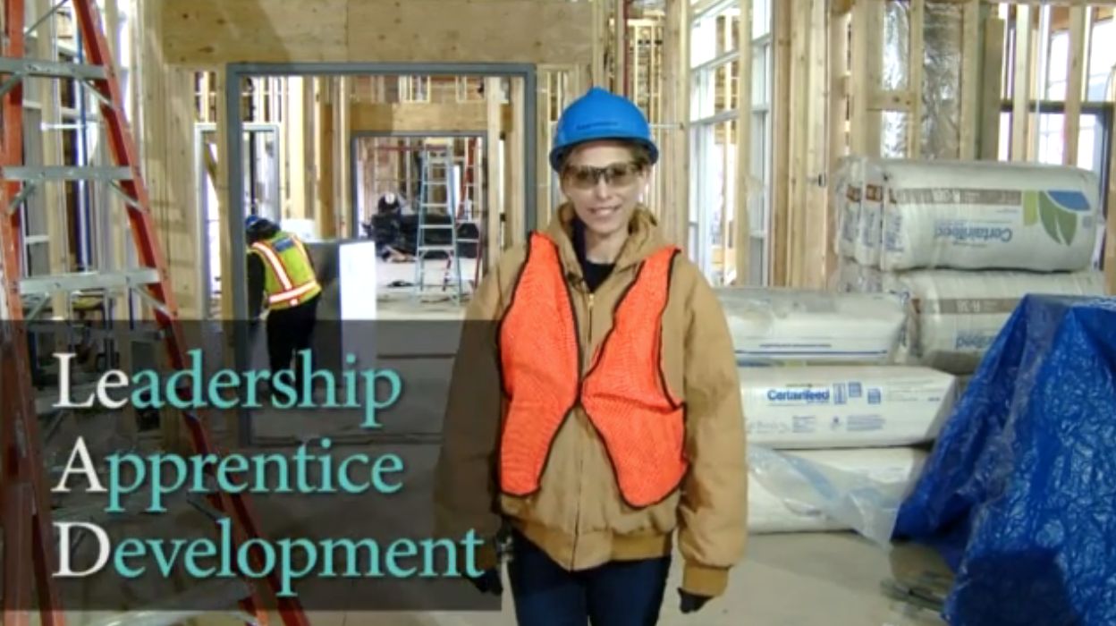
Introduction Module

Goal: Introduce students to leadership concepts
Length: 13 minutes

Purpose of Project LeAD

To help construction workers understand and develop their leadership capabilities for safety in the construction industry.

“OK lets get started! The introduction module of the video training is designed to introduce:

- The background behind how the training was developed
- The reason why the training was developed
- WHO leaders are on the job
- WHAT effective leaders can accomplish
- WHAT effective leaders do”

Play
Introduction Module video.

KEY POINTS OF THE MODULE
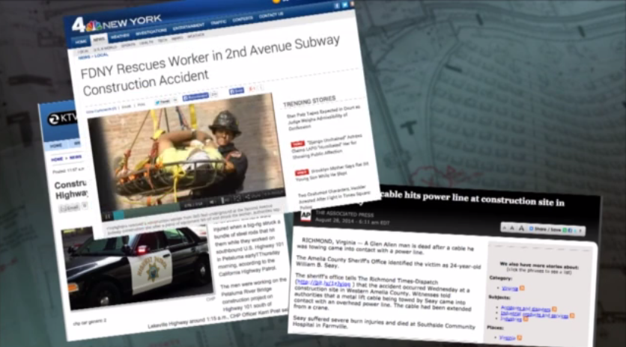
Background
One method of preventing safety incidents is to strengthen safety leadership skills of construction jobsite workers. This is because safety leadership is a key vehicle for creating and sustaining a positive jobsite safety culture.
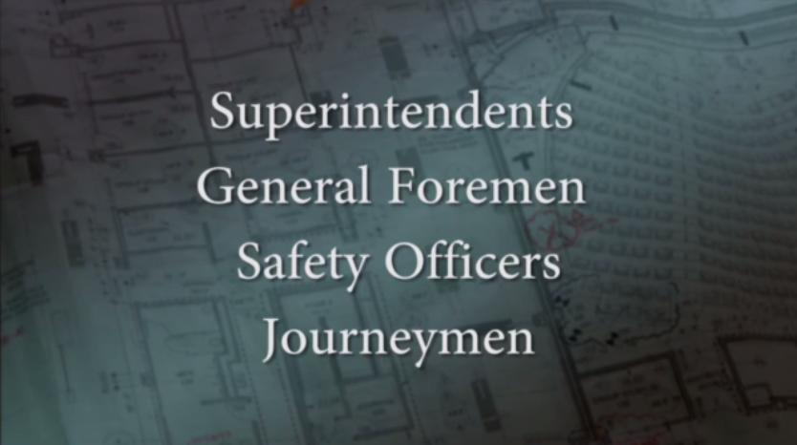
Who are safety leaders?
Any one on a construction jobsite can be a leader! Everyone listed on the right are the obvious answers, but apprentices can be leaders too!

It is everyone’s responsibility to ensure that a job runs safely and smoothly.
Apprentices!

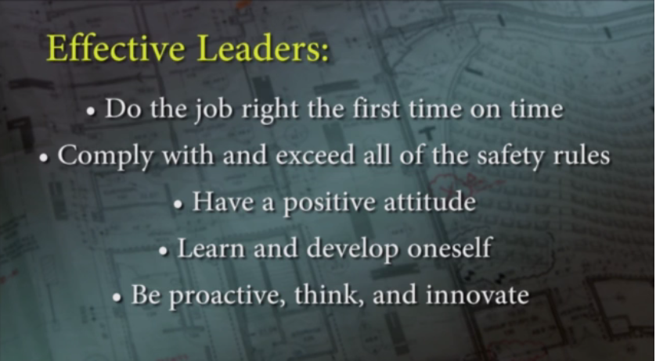
What can effective leaders accomplish?

Can you think of other outcomes of effective leadership?

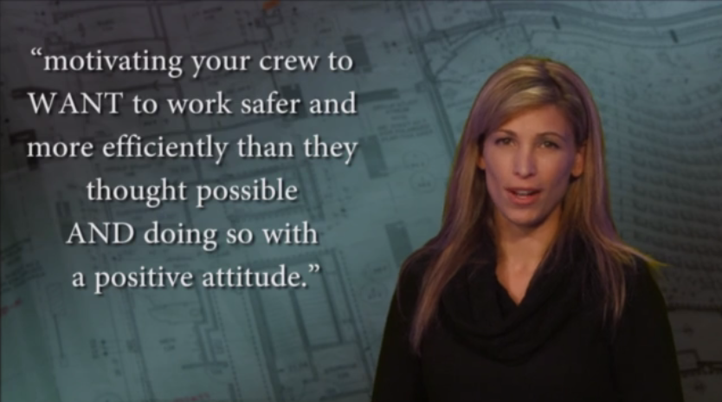
Definition of leadership in the construction industry

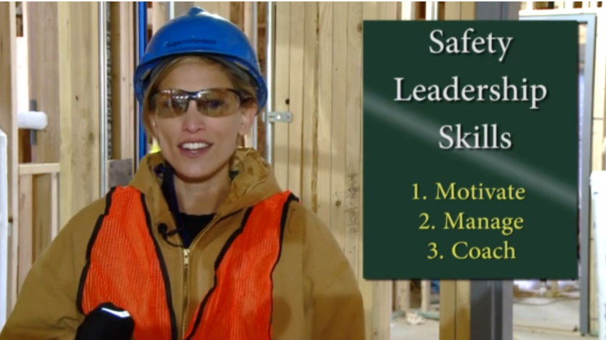
3 Safety Leadership Skills

Note the 3 safety leadership skills that are important for creating and sustaining a positive jobsite safety culture.

Pause before playing Module 1.
Pause

“Just as they said in the video, the skills you will learn about today CAN be developed. All you have to do is learn about them and start applying them on the job. So, as we go through the rest of the training video modules be thinking about how you can apply the leadership skills on your job sites.”

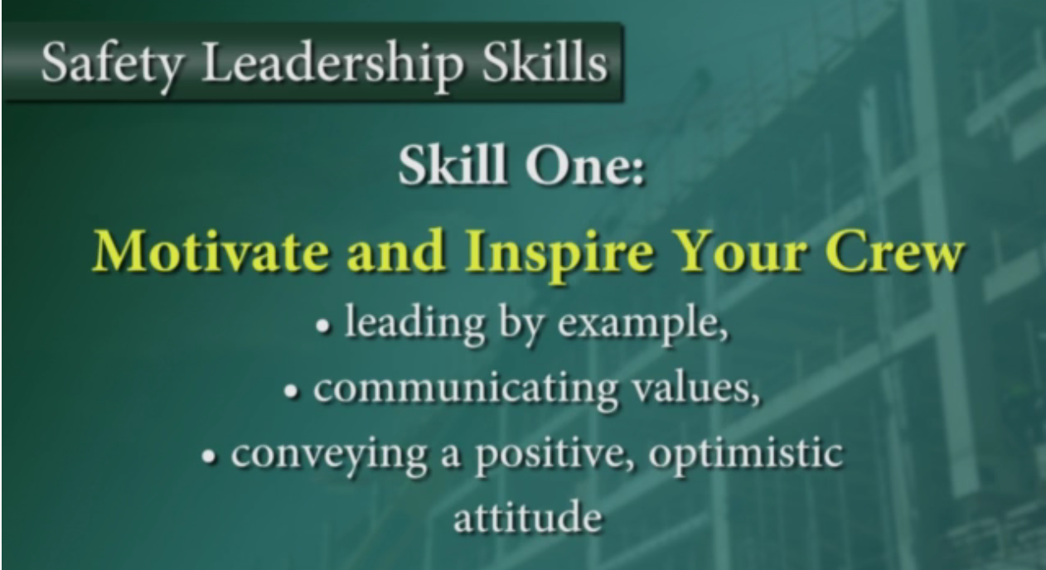
Module 1 – Motivate and Inspire Your Crew

Goal: Learn about motivating your team
Length: 10 minutes

“Module 1 will tell you about how to motivate your team. As a leader, you can do three things to motivate and inspire your team:

- Lead by example
- Communicate their values
- Conveying a positive, optimistic attitude”

“Lets hear what they have to say about these three things…”
Play
Module 1 video – Motivate and Inspire Your Crew.

KEY POINTS OF THE MODULE

Leading by example

This is the most common method to motivate workers.

- Show your team what’s acceptable and what’s not
- Take action to correct a safety hazard when needed
- Make the call to stop work if needed

Communicating values

Not only should you show your team what you value through your actions, you should also make sure your team hears about your values.

- What do you value?
- How can you communicate these values through your actions?

Convey a positive, optimistic attitude

Encourage your team in a positive manner.

- Be up beat, positive and express enthusiasm during work.
- Set high expectations for your team

Pause before playing Module 2.
Pause
Discussion with Class
After module 1 concludes, take some time to discuss examples of leaders your class and you have seen that are good at motivating and inspiring their crews.

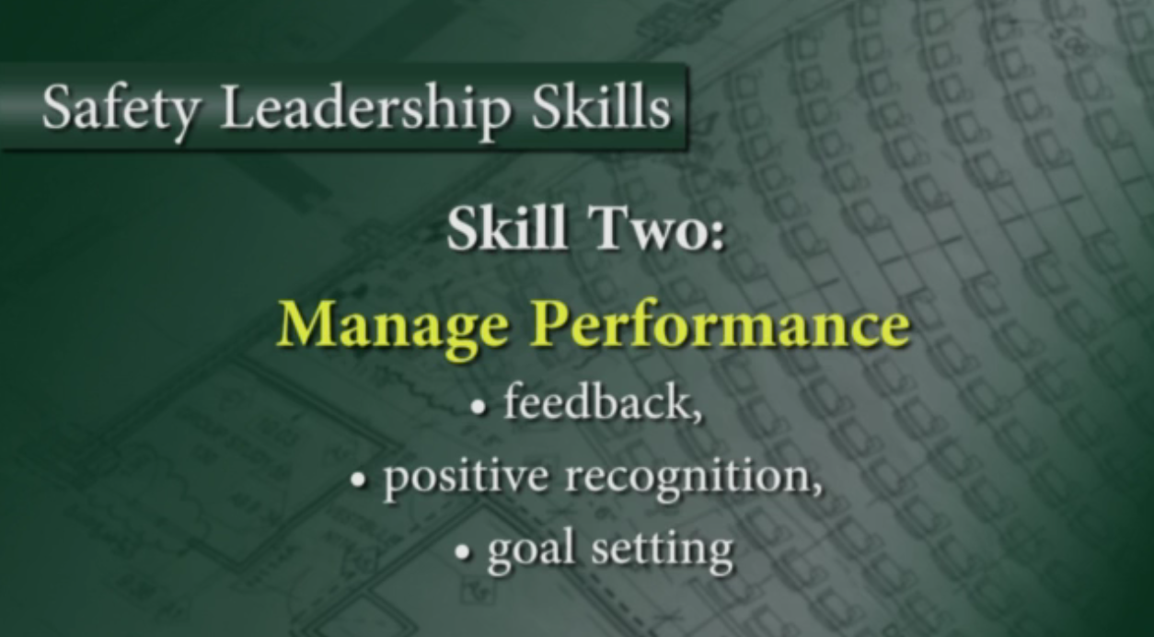
Module 2 – Manage Performance

Goal: Learn about managing teams
Length: 9 minutes

“Module 2 will tell you about how to manage your team. As a leader, you can do three things to manage your team:

- Give feedback
- Give positive recognition
- Goal set

“Lets hear what they have to say about these three things…”

Play
Module 2 video – Manage Performance

KEY POINTS OF THE MODULE

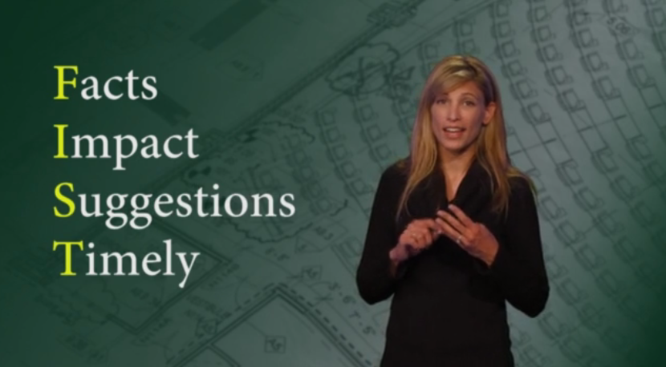
Feedback

Feedback helps people understand if they’re doing a good job or if they could be doing something better.

- Praise in public, criticize in private
- Use the FIST to remember how to give feedback
- Do not wait until the job is over!

Positive recognition

Let your team know you appreciate their effort on a daily basis.

- Ways to recognize team members:
  - Hand shake
  - Thank you on the spot or during meetings
  - Lunch
  - Mention feedback you got from upper management
  - T-shirts, safety stickers, gift cards

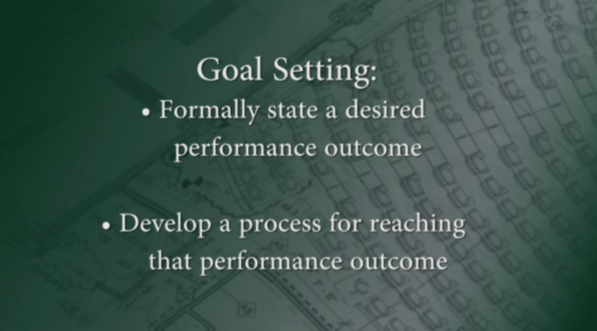
Goal setting

Goal setting can help individuals who are not performing to the best of their abilities, and to motivate individuals to continue performing well.

If you are given a task with no end in sight, it’s easy to complete it without realizing that you ever achieved something!

Create SMART Goals to help manage team performance. Specifically, what would you need to DO to achieve your goal – today, this week, this month? These can be small steps too. Use the cheat sheet on the following page to create SMART goals.
SMART Goals
- Specific
- Measurable
- Ambitious
- Realistic
- Time-based

SMART goals
Ask yourself:
Who is involved?
What do I want to accomplish?
When will it be done?
Where will this take place?
Why should this be done?
Specific:
What does the outcome of the goal look like?
Establish concrete criteria for measuring the outcome of the goal and progress toward the goal

Ask yourself:
How much?
How many?
How will I know when it is accomplished?
Measurable:
How will you know if you succeed?
If your goal is to spend 3 more minutes with your family per month, you will not find it motivating.

On the other hand, it cannot be impossible to attain or you will feel defeated

A goal must represent an objective toward which you are both willing and able to work

If your goal were to never be late again, what happens if you are late once?
Ambitious and Realistic:
To be motivating, a goal must be challenging to obtain

With no time frame, there is no urgency to your goal

But, if you can anchor your goal with an end date, you've set your unconscious mind into motion to begin working on the goal
Time-based:
Set a time frame

Pause before playing Module 3.
Pause

Discussion with Class
After module 2 concludes, take some time to discuss…
- How they can effectively manage performance of their team.
- Their thoughts about the FIST feedback method and how they can use it on the jobsite.
- Talk about leaders they have seen use feedback, positive recognition, and goal setting effectively. What did they do that they can use in their own co-workers on the jobsite?

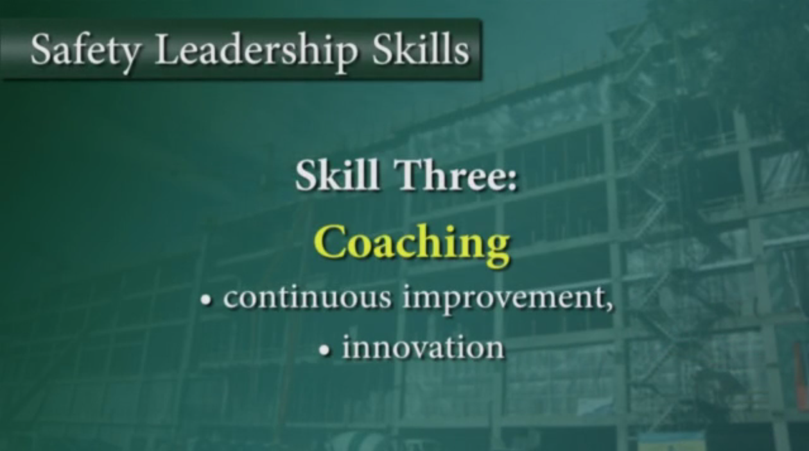

Module 3 - Coaching

Goal: Learn about coaching teams
Length: 10 minutes

“Module 3 will tell you about how to coach your team. As a leader, you can do two things to coach your team to continually improve and innovate with your crew:

- Be caring and treat people like individuals
- Teach
- Encourage innovative thinking and problem solving

“Lets hear what they have to say about these three things…”

Play
Module 3 video - Coaching.

KEY POINTS OF THE MODULE

If you motivate your team and you put forth effort to manage their performance, you will be an effective leader today. If you want to take your crew and your organization to the next level, you need to coach your team for continuous improvement an innovation.

Listen, show compassion, and treat people like individuals
- Negativity, yelling and screaming will not inspire your team
- Adapt to the individual needs of your team
- Show your team that you care about each of them

Teaching
- Give your team a hands on learning experience
- Have patience when teaching
- Do not belittle
- Teaching increases skills and motivation

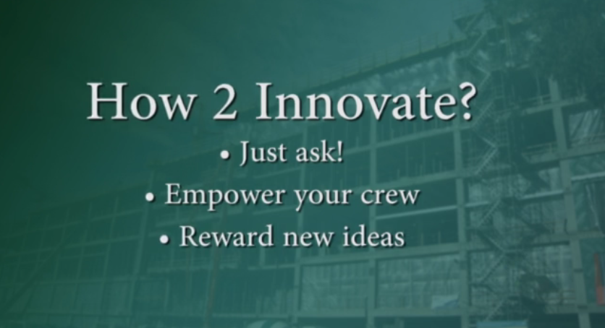
Innovation
- Your team should feel like they are all a part of finding solutions and decision making
- Encourage problem solving

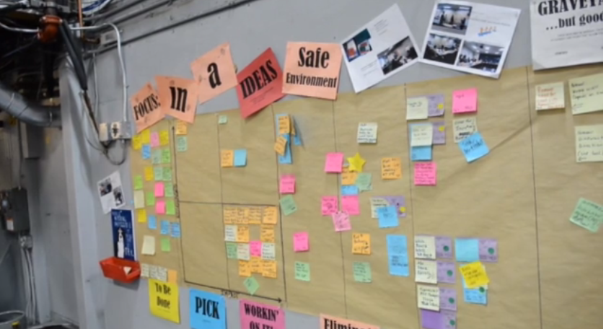
- TIP – Create an idea board for everyone to post ideas to improve safety, productivity, and the quality of your product. Review the board frequently with your team and take action.

Pause before continuing to the Summary Module.
Pause

Discussion with Class
After module 2 concludes, take some time to discuss…
- What can you do to effectively teach on the job and get others to think for themselves?
- What are the benefits of coaching on the job?
- What advice would you give another apprentice on how to be a better coach?
- What are some specific things you can personally do now to be a better coach?
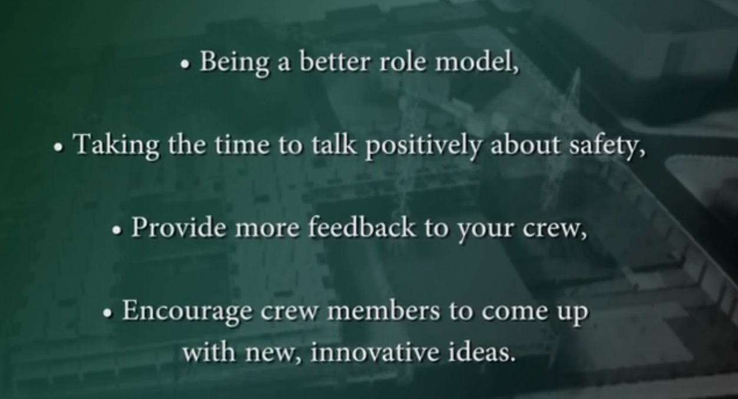
Summary Module

Goal: Summarize leadership skills and goal set
Length: 5 minutes

“The summary module will help us sums up the three safety leadership skills you learned about, and tell you about the outcome of effective leadership. She’ll also have you start thinking about goal setting. Lets listen.”
Play
Summary Module video.

KEY POINTS OF THE MODULE

Effective leadership results in:
- Greater productivity and a successful business
- Team safety and health
- Learning
- Positive moral
- More motivation

Remember You’re not going to prove yourselves over the next week, you’ll prove your leadership capabilities over the next 10 years!

Stop video and facilitate a goal setting activity.
Pause

This is the end of the training video. However, you should continue to help your class think about the material and how they can apply the safety leadership skills they learned about to their jobs. You can do this by walking them through the goal setting exercise below.

