CPWR Research to Practice (r2p) Roadmap Tool

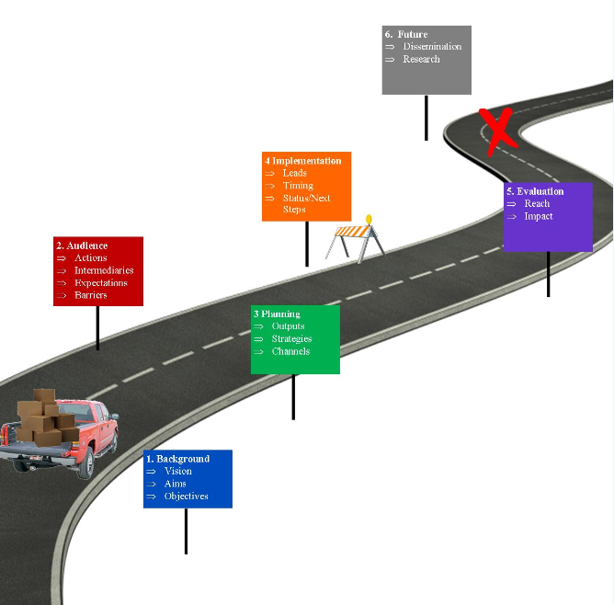
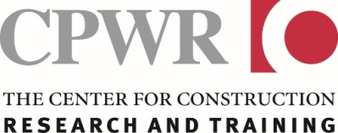
©2019 - The r2p Roadmap is a product of CPWR-The Center for Construction Research and Training’s Research to Practice (r2p) initiative, which aims to promote research dissemination and encourage widespread adoption of evidence-based safety and health solutions in construction. All rights reserved. Production of this document was supported by cooperative agreement OSH 009762 from the National Institute for Occupational Safety and Health (NIOSH). The contents are solely the responsibility of the authors and do not necessarily represent the official views of NIOSH.

The Research to Practice (r2p) Roadmap Tool is designed to help you develop a written strategy for ensuring that your research findings and interventions reach and are used by your target audience(s). It consists of two documents:
- This r2p Roadmap Worksheet to use to develop a plan for disseminating your research. It is set up as a Word document so that you can easily modify it to meet the needs of your project and research team.
- The r2p Roadmap Guide, which contains information and examples to help you complete each section of this Worksheet.
This Worksheet has six sections that build on each other. Each section includes the page number(s) in the Guide where information can be found to help complete that section.
When developing your Roadmap:
- Start your r2p Roadmap early in your research project. It is never too early to start planning for the successful dissemination and implementation of your research findings. Your research plan should include how your findings and interventions will be used.
- Engage your audience and intermediaries early in the development of your r2p Roadmap. Involving those who will ultimately use or influence the use of your research findings will help to ensure that your dissemination plan is realistic and can be effectively carried out.
- Involve everyone on your research team in completing the Worksheet. Consider having the research team, as well as representatives from your target audience(s) and intermediaries, work together to complete the Worksheet, rather than having a lead individual draft the document and then doing rounds of revisions with other team members. Research teams have found that this helps to get everyone on the same page, leads to creative brainstorming, and often identifies areas that need to be discussed in more detail.
- Treat your Roadmap as a living document. As a living document, it is meant to be changed and amended as your research progresses, as you learn more about your partners and target audience(s), and as conditions and contexts evolve. Review and update your Roadmap as needed, at least once a year over the project’s duration. At the start of your project, there may be questions and sections of the Roadmap that you are not able to answer or complete with the information available. As your research progresses you may need to change your plans based on what you learn; this is fine and to be expected.
- Keep track of key changes to your Roadmap. It is helpful to keep track of changes made and the reasons for making them. Consider entering notes on new information or developments that led to a change in direction in a different text color, using the “Notes” section of each step, or as footnotes or endnotes.

Project Title ____________________________________________________

Project Team Members | Role

Dates your Roadmap was first completed & revised (MM/DD/YYY):  (Revisit your Roadmap at least once a year) | Names of team members who completed or revised it:

NOTE: To insert additional rows or columns in a worksheet table: 1) highlight the row or column; 2) with the row or column highlighted, right click and select ‘insert’ and select the option (insert below, above, etc.)
Section 1: Background (Using your project proposal as a starting point, summarize your vision (overarching goal for the project), research aim(s), objectives, and any outreach activities conducted so far. See pp. 3-4 in the Guide for help.

Vision (overarching project goal). Example: The tool developed through the research is commercially available and the industry norm.

Research Aim(s) & Objective(s). An Aim is what you want to accomplish; an objective is how you plan to do it. Each Aim can have more than one objective. Include all the Aims in your project. Insert additional lines as needed. (p.3)
Aim(s) identified in your project | Objective(s)

Dissemination Already Conducted. Only complete this table if this project is a continuation of an earlier project or if you had already begun outreach activities before using this Roadmap tool. Insert additional rows as needed. (pp. 3-4)
Research Aims | Research outputs (e.g., a tool, translational product) already disseminated | Dissemination already conducted, including audience(s)
#1
#2
#3

Notes
Section 2: Audience Profile(s) (See pp. 4-8 in the Guide: Who do you want to reach with your research finding(s)/ intervention(s) and what do you know about those audience(s)? Be as specific as possible. Start a new row for each audience.)

Key Audience(s) (i.e., masonry workers, electrical contractors) (pp. 4, 7) | Preferred way to receive information (pp.4-6) | Language or literacy concerns (i.e., native language Spanish) (p.6) | Desired action. What do you want your audience(s) to do, think, or believe as a result of having access to the information or output from your research? (pp. 6-7)

Who can help you reach your key audience(s)?
Key Audience(s) (copy from above) | Intermediaries (e.g., groups or individuals who can help you reach the audience) (p. 7) | Expectations (what would you want the intermediary to do?) (p. 7)
Key Audience(s) (copy from above) | Potential barriers to reaching audience (pp. 7-8) | Ideas for overcoming barriers (pp. 7-8)

Notes
Section 3: Dissemination Planning (See pp. 8-11 in the Guide.)
Research Outputs (e.g., training, a tool, article, report, work practice, translational product) (pp.8-9) | Key Audience(s) (from Section 2) | Dissemination Strategy(ies) (e.g., education, social marketing) (pp. 9-10) | Communication  Channel(s) (e.g., webinar, social media, events/ meetings) (p. 10) | Resources needed to implement strategy (pp. 11)

Notes
Section 4: Dissemination Implementation – Timing, Status, and Next Steps (Copy and paste information from on the previous worksheet in the first four columns. See p. 11 in the Guide.)
Key Audience(s) (from Section 3) | Research Outputs (from Section 3) | Dissemination Strategy (from Section 3) | Communications  Channel  (from Section 3) | Timing (target for when you will carry out the strategy/ activity) | Lead (the individual(s) participating in the research responsible for ensuring the action is taken) | Status/ Next Steps

Notes
Section 5: Evaluation (What measures will you use or should be used to determine if your research finding is reaching users, being used, and having the intended outcome? See p. 12 in the Guide.)
Key Audience(s) (from Section 4) | Research Outputs (from Section 4) | Reach of Outputs (measures of and actual numbers reached) | Impact Measures (measures and indicators that your research is having its intended impact on the audience – adoption of a tool, work practice, injury reduction, etc.)

Notes

Section 6: Future Dissemination & Research Questions (Complete in the final year of the project. See pp. 12-13 in the Guide.)
Dissemination recap (describe the activities you were not able to complete and why, including factors that hindered your efforts) (p. 12)

Future dissemination steps (to be undertaken outside of this project) (p. 13) | Who might take them on?

Future research questions (p. 13)

